Overview of Cloud Computing Definition and benefits of cloud computing.

Tasks

1.Sign up for a free AWS or Azure account and log in to the Management Console. Take a screenshot of your dashboard showing your name or email in the top bar.

ANS:

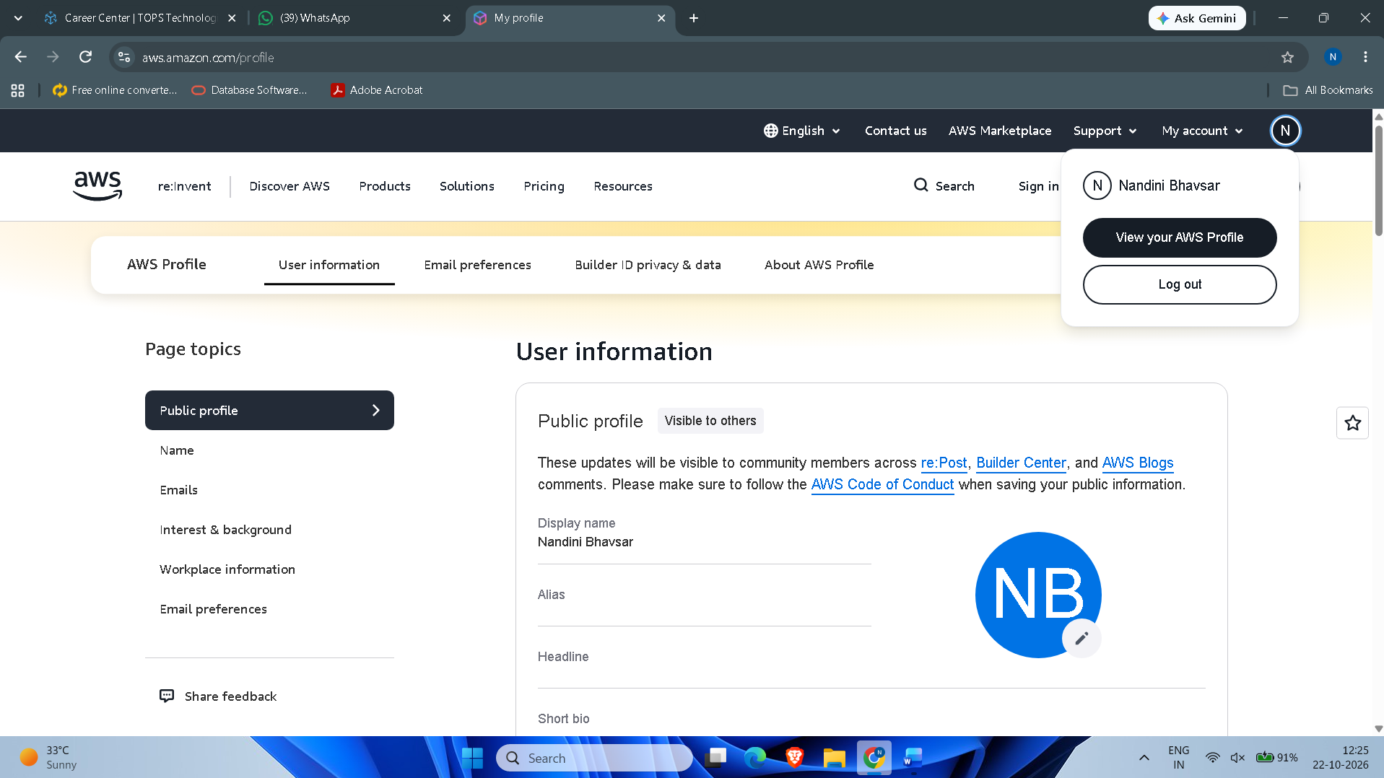

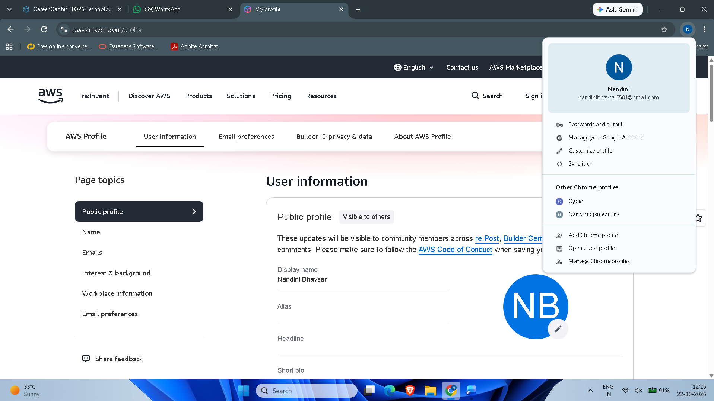

2. In the AWS or Azure Management Console, locate and list 5 key services (such as Compute, Storage, Database, Networking, Analytics). For each, write one line describing what it does and name one real app (like Instagram, Zomato, Flipkart) that could use it.

ANS:

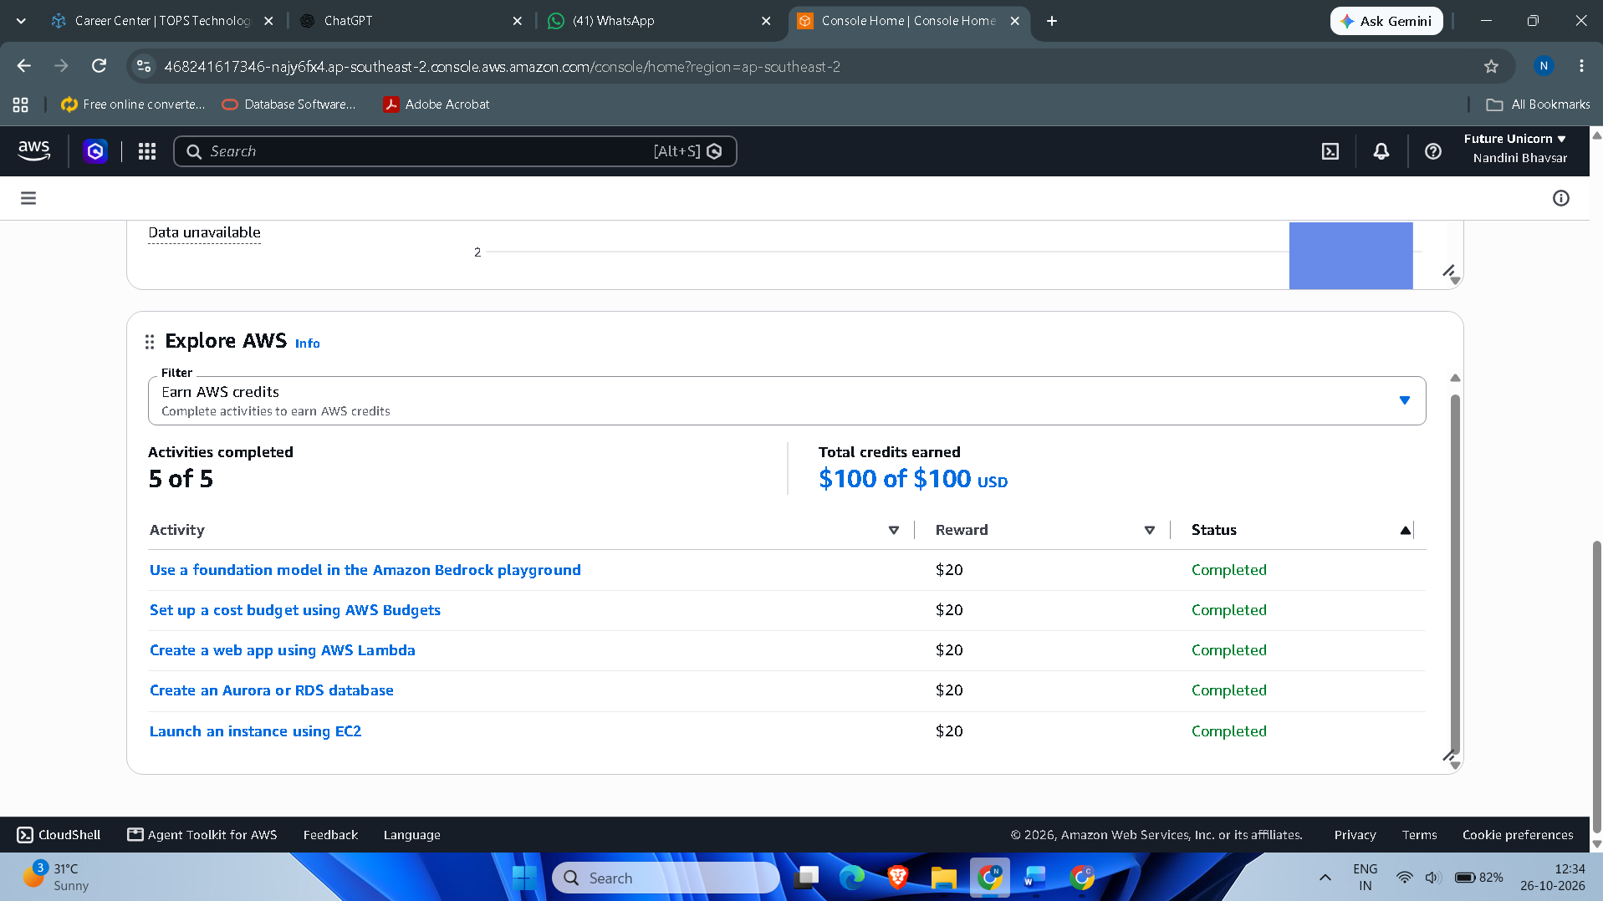

No. | AWS Service | Category | Description | Real-World App
1 | Amazon EC2 | Compute | Provides virtual servers to run applications and websites. | Instagram
2 | Amazon S3 | Storage | Stores files, images, videos, and backups securely. | Zomato
3 | Amazon RDS | Database | Stores and manages structured data for applications. | Flipkart
4 | Amazon VPC | Networking | Creates a private, secure network for AWS resources. | Paytm
5 | Amazon Redshift | Analytics | Analyses large amounts of data to generate reports and insights. | Netflix

3. Use the search bar in your AWS or Azure Console to find the S3 (AWS) or Blob Storage (Azure) service. Write down the steps you took to locate it and describe in 2-3 lines how a music app like Spotify could use this service to store user-uploaded files.

ANS:

Steps I took to locate Amazon S3

- I logged in to the AWS Management Console.
- I clicked the Search bar at the top of the console.
- I searched for S3.
- I selected Amazon S3 from the search results.
- The Amazon S3 dashboard opened, showing the option “Create a bucket.”

How Spotify Could Use Amazon S3:
Spotify could use Amazon S3 to store user-uploaded audio files, podcast recordings, and album artwork. It provides scalable and durable storage, allowing the app to store and retrieve media files whenever required.

4. Pick one key characteristic of cloud computing (on-demand self-service, broad network access, resource pooling, rapid elasticity, or measured service) and explain, in your own words, how it benefits users of a popular app you use daily (e.g., Paytm, BookMyShow, IRCTC). Think about how these apps handle sudden spikes in users or data

ANS:

Characteristic: Rapid Elasticity
I use Paytm daily for online payments and recharges. Rapid elasticity means cloud resources can automatically increase or decrease according to user demand. For example, during festivals or cashback offers, when many users make payments at the same time, Paytm can use additional cloud resources to handle the increased traffic. When traffic decreases, those resources can be reduced.
Benefit: Payments remain fast and smooth, and the app can handle sudden spikes in users without easily slowing down or crashing.

